|  |  |  |
| --- | --- | --- |
| MONTESSORI MAGNET SCHOOL  ALBANY - SCHOOL |  |  |
|  |  |  |
| School Detail :- The Montessori Magnet School provides a national model for excellent public Montessori education.The school serves the Greater Hartford community.  The Montessori Magnet School provides a national model for excellent public Montessori education. The school serves the Greater Hartford community, offering a traditional Montessori education for students ages 3-12, extended child care for students participating in the full-day program and a diverse environment in our custom-built school facility.   Students progress academically and socially through an integrated curriculum that combines the Montessori pedagogy with highly effective instructional strategies. |  |  |
|  |

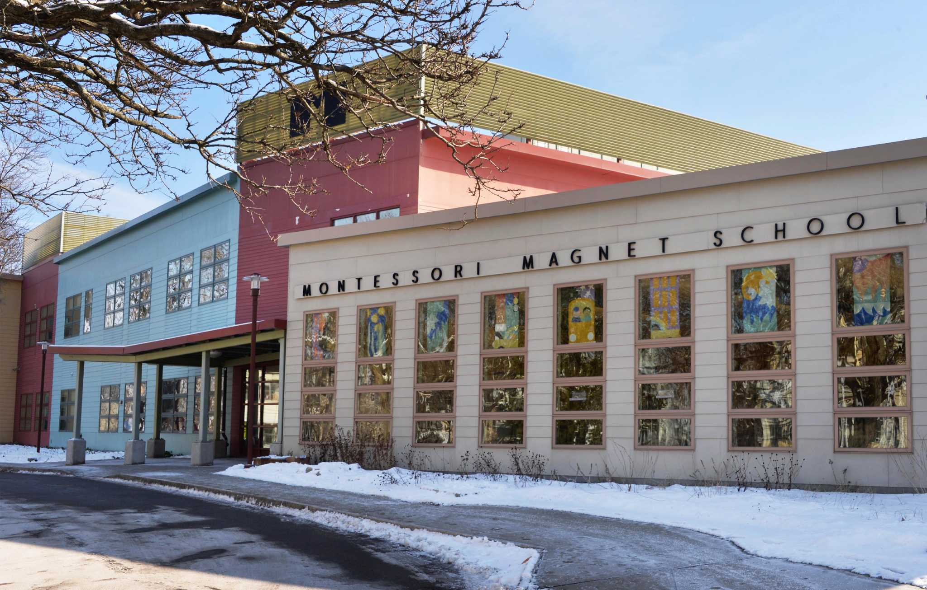

MINIMUM CAPACITY :-

The Minumum intake capacity

of students is between 280-310

children

LIBRARY :-

The Libarary is Available.

CANTEEN:-

The Canteen Facility is Available.

BOARDING :-

No availablility of boarding.

SPORTS :-

There are different categories

sports available.

Girls Volleyball

Boys Volleyball

Football